**Launch Database**

**Step 1:**Select manage after adding new credentials.

**Step 2**:click on Launch Dashboard to redirect to database page.

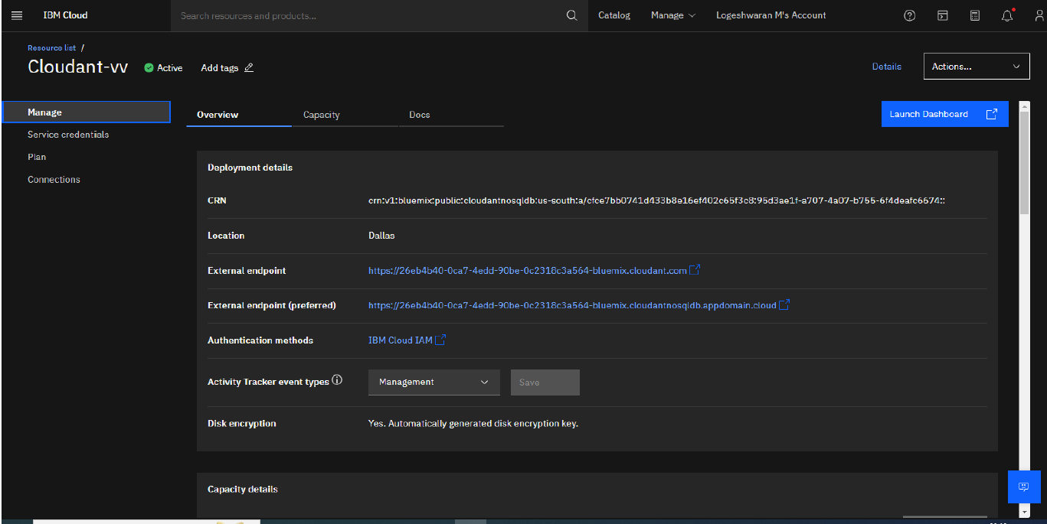

**Step 3**:Then click create Database and type database name.

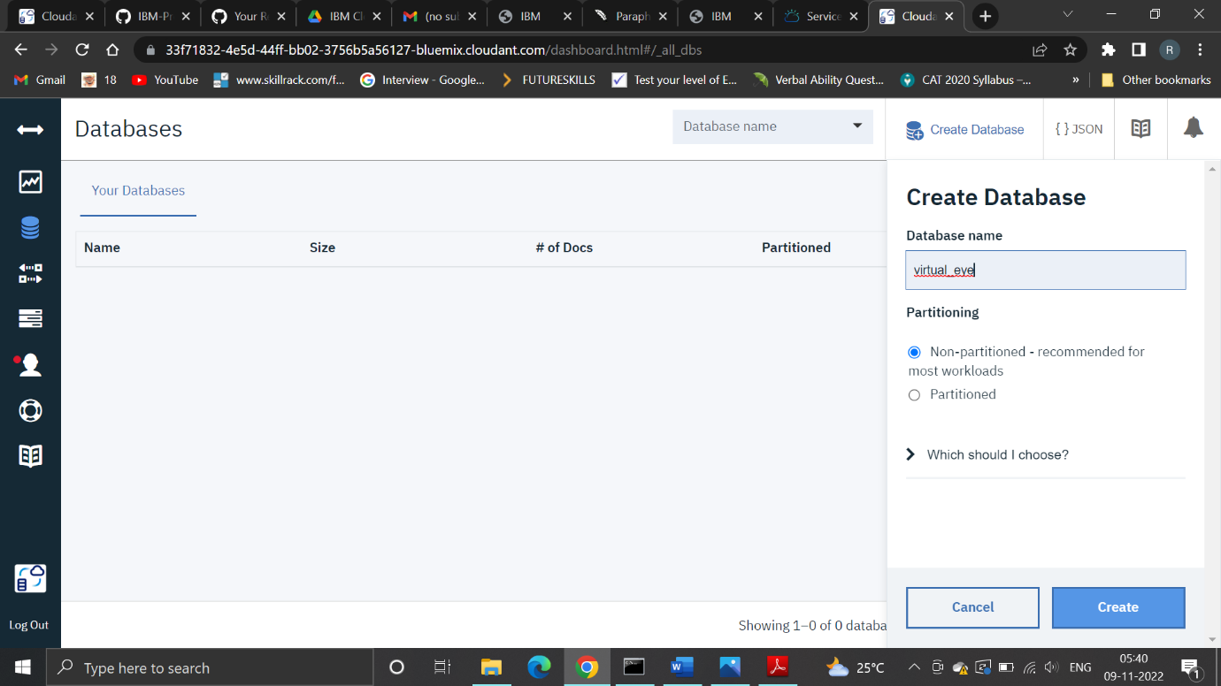

**Step 4**:Now select Partitioning and click create.

